 Introduction to Robotics

Group 13

Week 06 Date 27/02/15

Fergal Lonergan, Ruairí O’Donoghue, Kevin O’Flannagáin

**Assignment:** 3 [Warehouse](https://csimoodle.ucd.ie/moodle/mod/resource/view.php?id=27804)

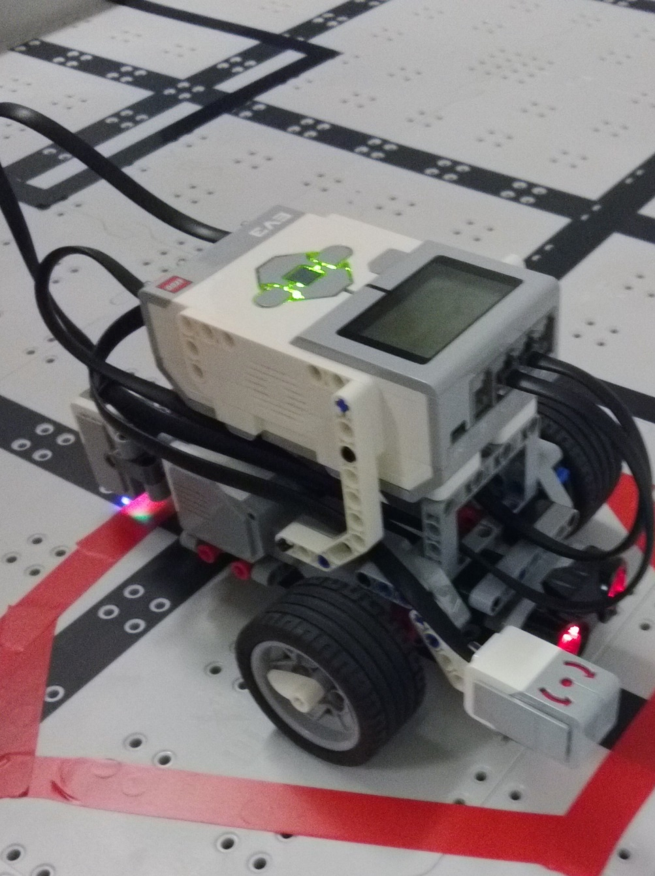Robot used for assignment.

**Goal:** The goal this week was to develop a program to navigate a ‘[Warehouse](https://csimoodle.ucd.ie/moodle/mod/resource/view.php?id=27804)’. The robot was to use our choice of sensors (though we were told that the ideal method would be to use some variation of our line sensing function from the previous week). The program had to be able to get through the obstacles to the goal area without crossing the blocked off sections on the table (marked with black tape).

**Robot design:** We decided to move the colour sensor to the left side of the robot slightly (but kept it at the rear), to avoid going over one of the lines parallel to the direction we wanted the robot to travel. We added on the gyro sensor to our robot but after some testing we decided against using it until we could figure out how to optimise it for our robot and it was removed. The ultrasonic sensor was left in the centre of the robot facing forwards as it was needed for our program, and the touch sensors were disconnected as they were not needed for this assignment.

**Programs:** The colour sensor was used to count how many lines had been crossed by the robot. We stored this information in a variable and used it to deduce where about the robot was in relation to the obstacles and the goal area. Our program had the robot cross over 3 black lines before it turned left 90 degrees to fit in between the two obstacles on the table. The robot then carried on in a straight line until it was within 10 cm of the wall (checked this using the ultrasonic sensor on the front of the robot). A 90 degree turn to the right was performed and the robot moved forward before coming to a stop in the goal area.

**Learned:** In this challenge we learned that there is a trade-off between the speed of the program and the precision and consistency of turns and moving in a straight line. We also experimented with the robots gyro sensor but found that it was not accurate enough to warrant use (perhaps because of the general speed of the robot in our program).

**Finished Code:** While many other groups decided to use a certain percentage of the robots top speed, our program for the most part utilized 100% of the motors’ capacity. This made it slightly more difficult for us as the robot was more prone to small changes in performance due to wheel skidding or going from top speed to zero in an instant. We felt that these small inaccuracies were worth the trade-off for a faster completion time of the challenge. Our program was one of the fastest (if not the fastest) when compared to the other groups.  
Our line counting function was designed in such a way that it would only count 1 for each line it crossed as opposed to looping each millisecond or so and counting multiple lines in the time it took to cross over one line.

**Work Distribution:** Ruairi handled most of the coding for this challenge while Kevin and Fergal made the necessary modifications to the physical build of the robot and handled most of the testing and recording aspects.

All of us wrote bits of the report, assigned for the most part by how much time that person spent on that particular area during the lab.